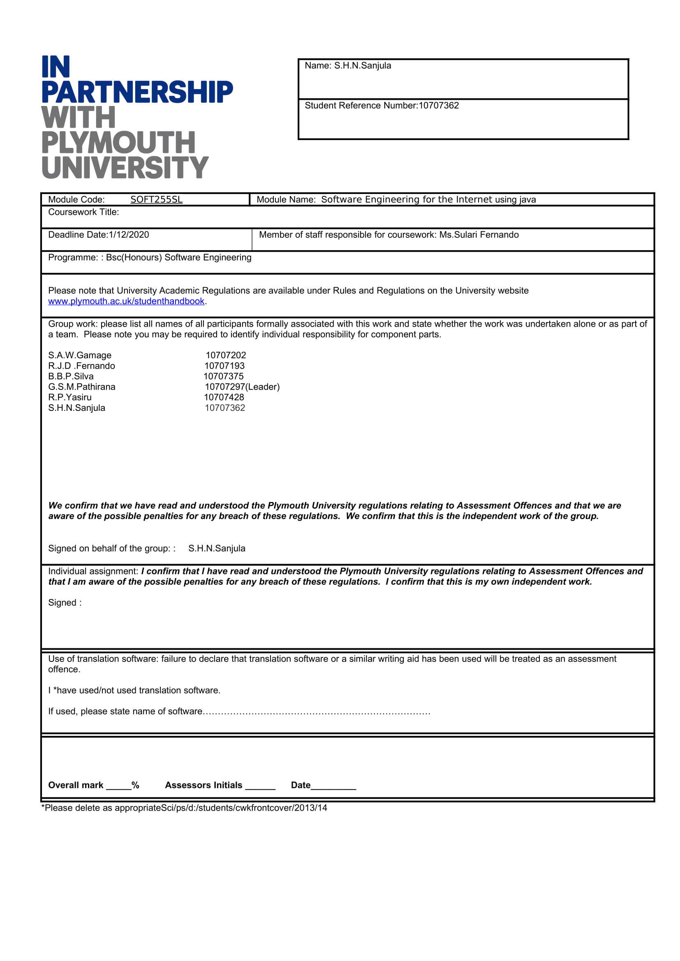

Table of Contents

Acknowledgement 3

Introduction 3

Aim 3

Main objectives 3

Scope 4

Benefits of the System 4

Functional Requirements 5

Non Functional Requirements 5

Performance requirements 5

Entity Relationship Diagram 6

use case diagram 7

Class diagram 8

System abouts 9

References 24

# Acknowledgement

We would like to express our gratitude to our lecturer Ms.Sulari Fernando.Who gave us the golden opportunity to create our own website,which also helped us in doing a lot of research and we came to know about so many new things that we are really thankfull to.

# Introduction

With the development of the technology many fields of the world have been changed and upgraded .so we developed a Resturant Management software for the resturant of the NSBM university . with this resturant management software the resturant can view their orders,can bill prints of the purchased food items,can mange their stocks,can keep records of their employees ,can manage supplier details,can view their menu and prices of the resturant menu,can keep records of their customers. so using this resturant management system the resturant can easily manage their work and can increase their productivity.

# Aim

The aim of this project is to develop a real time desktop resturant management system for the resturant of the NSBM university.

# Main objectives

* Develop an desktop application for managing purpouse of the resturant
* To manage the stock of the resturant
* To keep a record of purchased bills
* Print and provide a bill to the customer
* To manage suppliers of the resturant
* To manange employees details of the resturant
* To view menu prices of the resturant

# Scope

Scope of the resturant management system includes management of stocks of the resturant system,management of the purchases done by the customers,managing the suppliers who provides essential products to the resturant,management of the customer details and management of the emplooyes of the resturant.Many resturants manage their resturants manually without using automated softwares. So we developed a desktop application software to manage the entire resturant using the software very easily.

# Benefits of the System

Can track sales

Using the resturant management system we can track sales which keeps occuring many times a day very easily.so if we can track sales from the software we can identifiy our profits and loss of the resturant. With the assistance of this information, you will watch your things sold. This implies it gives the ability to settle on better choices for your business

Reducts errors

Recording orders for kitchen staff that outcomes in certain errors being produce because of the hand writing might be indecipherable. With the assistance of this software , orders are appeared on the screen. Along these lines, there is less possibility that the individual setting up the requests can make blunders.

Effective use of human resources

Building up the café the executives programming which assists with opening up the staff from performing tedious assignments. The undertakings, for example, physically executing the sales register reconciliation and twofold checking disparaties in deals. Consequently, time spare will faithful to better client assistance, and the potential for expanded benefit in computerized resturant management (Elysiumservice, n.d.)

# Functional Requirements

* Should be able to view the menu
* Should be able to signup and signin to admins
* Should be able to signup and signin to users
* Should be able to search resturant menu
* Should b able to add,delete , search,edit employee details
* Should b able to add,delete , search,edit customer details
* Should b able to add,delete , search,edit supplier details
* Should b able to add,delete , search,edit stock details
* Should be able to print a bill
* Should be able to view previously printed bills
* Should be able to purchase food items

# Non Functional Requirements

* Should be easy to interact (responsive)
* Should have good security
* Should be a user freiendly interface
* Should be able to secure the privacy of the user

# Performance requirements

* Shall be able to run in a pc
* Should have minimum or 2gb RAM
* Should have 2gb of hdd space

## Entity Relationship Diagram

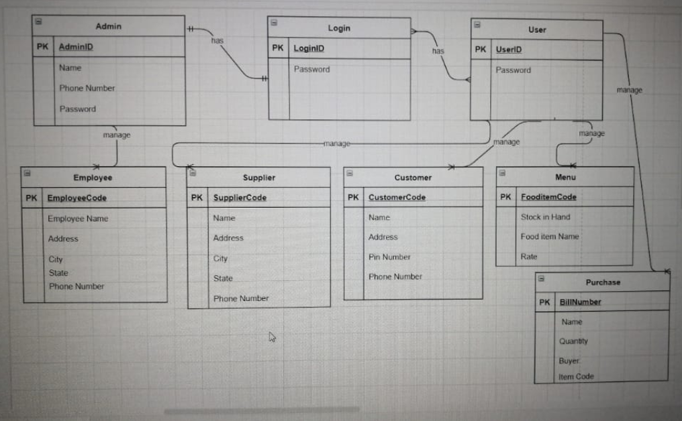

Assumptions

* there is only one admin
* there can be many users
* only one user can manage many employees
* only user can manage many customers
* only oneuser can manage multiple menus
* user can manage mutiple suppliers

# use case diagram

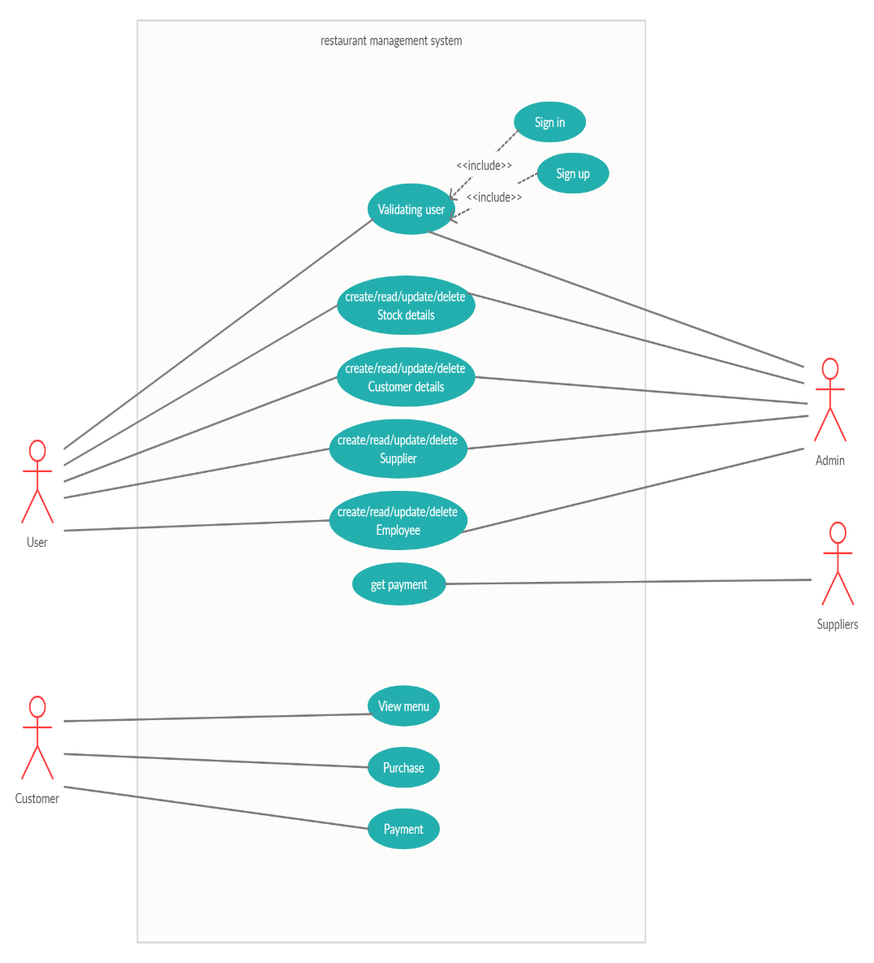

# Class diagram

# System abouts

To register to the resturant management system user has to eneter his or her name ,phone number, password.if the entered data are incorrect a message is displayed user details are incoorect.if the user entered the correct data a message is displayed welcome user .after userhas signed up to the system then the user can use his id and password to log into the resturant Management system.

Then there is the dashboard which the user can acesss many fields such as menu,supplier ,purchases,customer,employeee details and stock.

User can view the menu prices,menu name quantity and stock in hand by using the menu button and user can search menu items using menu id or food item name

User can insert employee code,name,address,state,pin number,phone number using the employeee insert button.also user can delete the records of employees using employee code.user can also edit the employee details using employee id

User can print a bill using purchase it displays bill number,buyer,name ,date of bill ,itemcode,item name ,quantity in the bill given to the user.also user can calculate the bill using the quick purchase .

From the supplier panel user can enter supplier code,name,address,city,state,pinnumber,phone number and the inserted data is showed in a data grid view.user can search suppler details by searching supplier code and also delete supplier records using supplier code

From the stock panel user can enter user can enter food item code ,item name,rate,stock in hand so the inserted data are shown in a data grid view .user can delete ,search,edit stock details using the food item code.

From the customer panel user can insert customer code ,customer name,customer address,city ,state,pin number,phone number and it shows using a data grid view .user can delete ,update ,edit records using customer code

User login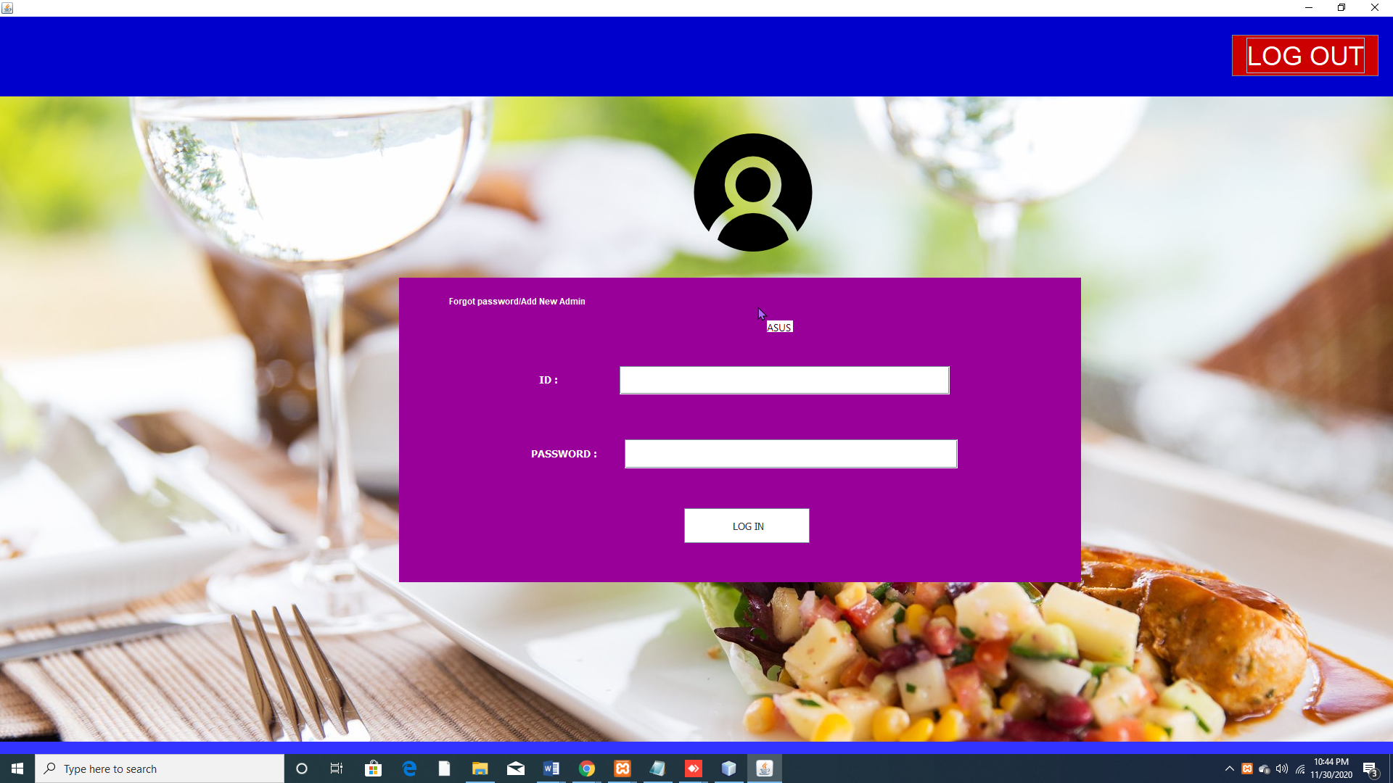

User signup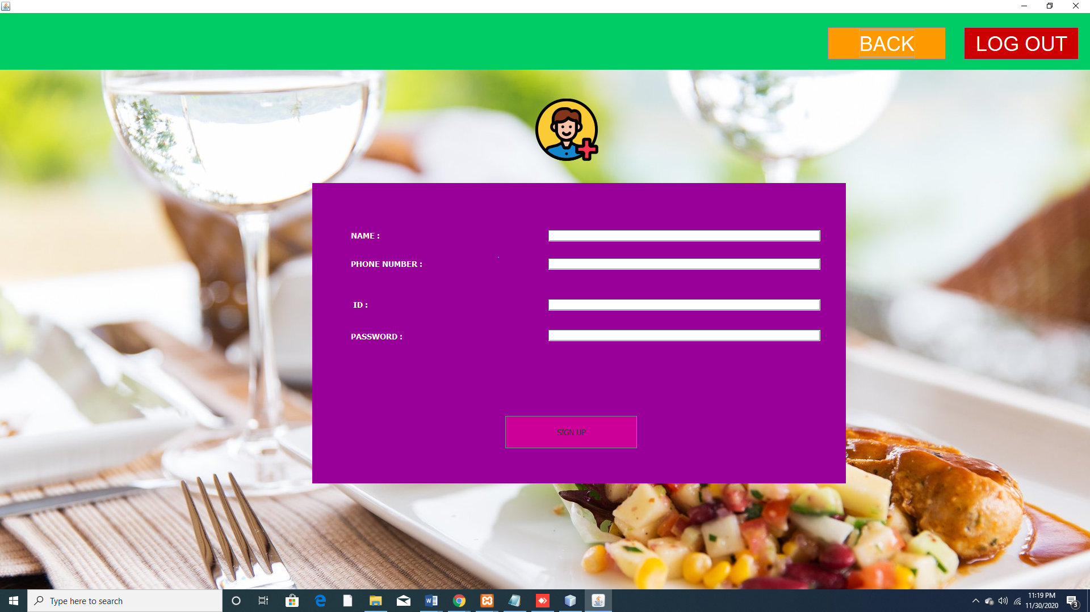

Dashboard

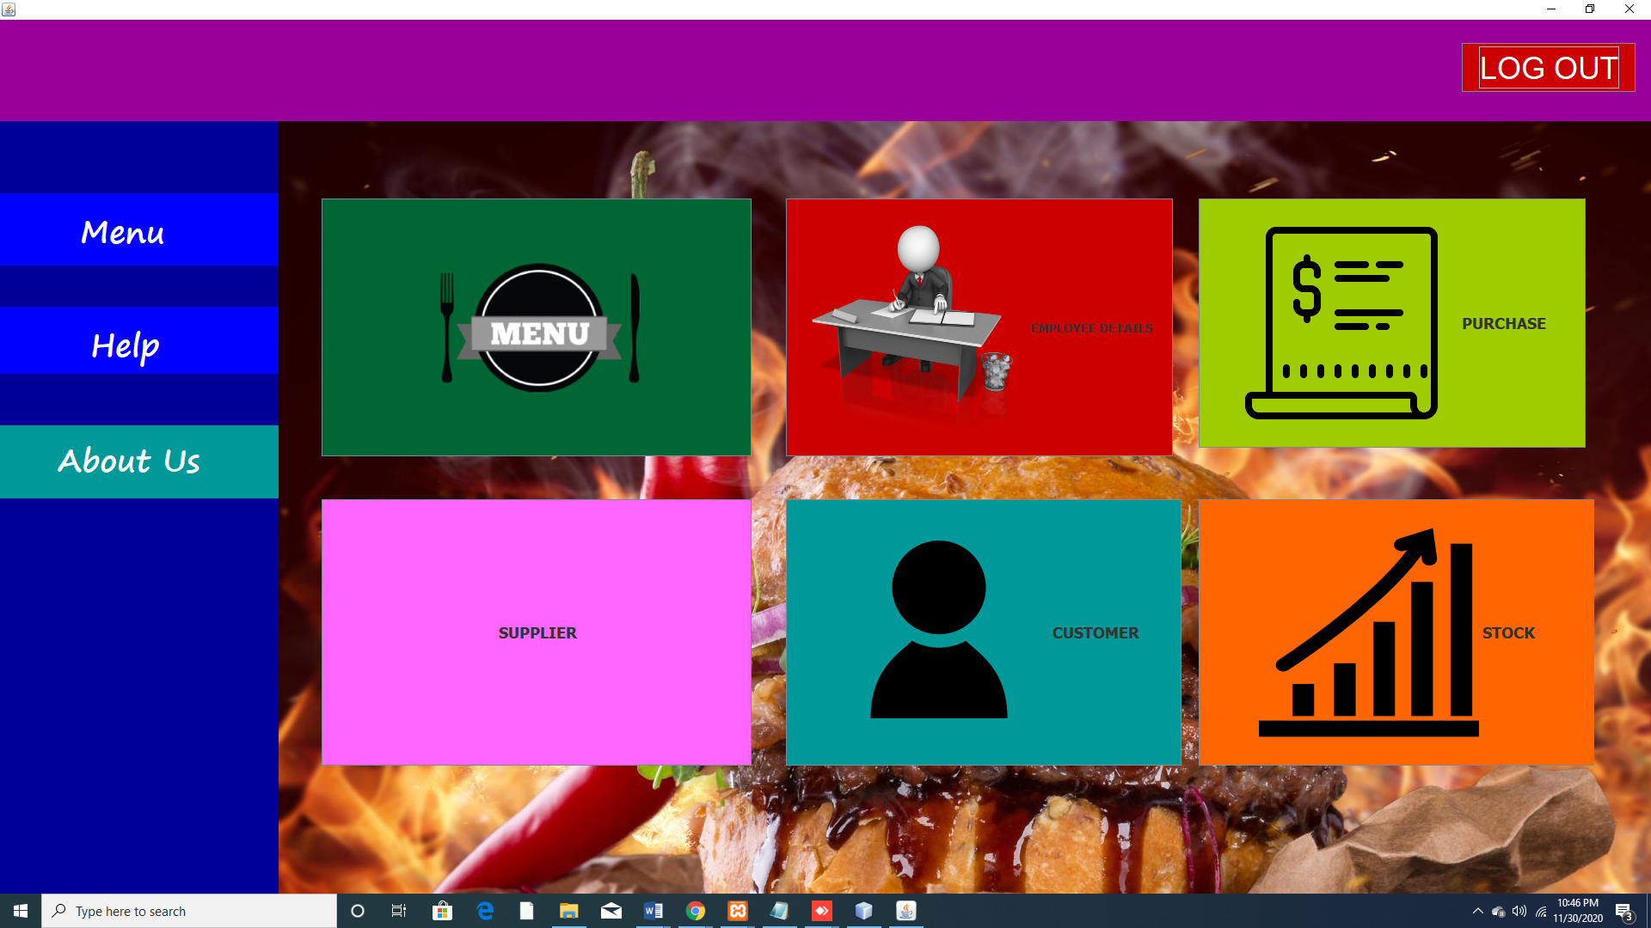

Menu panel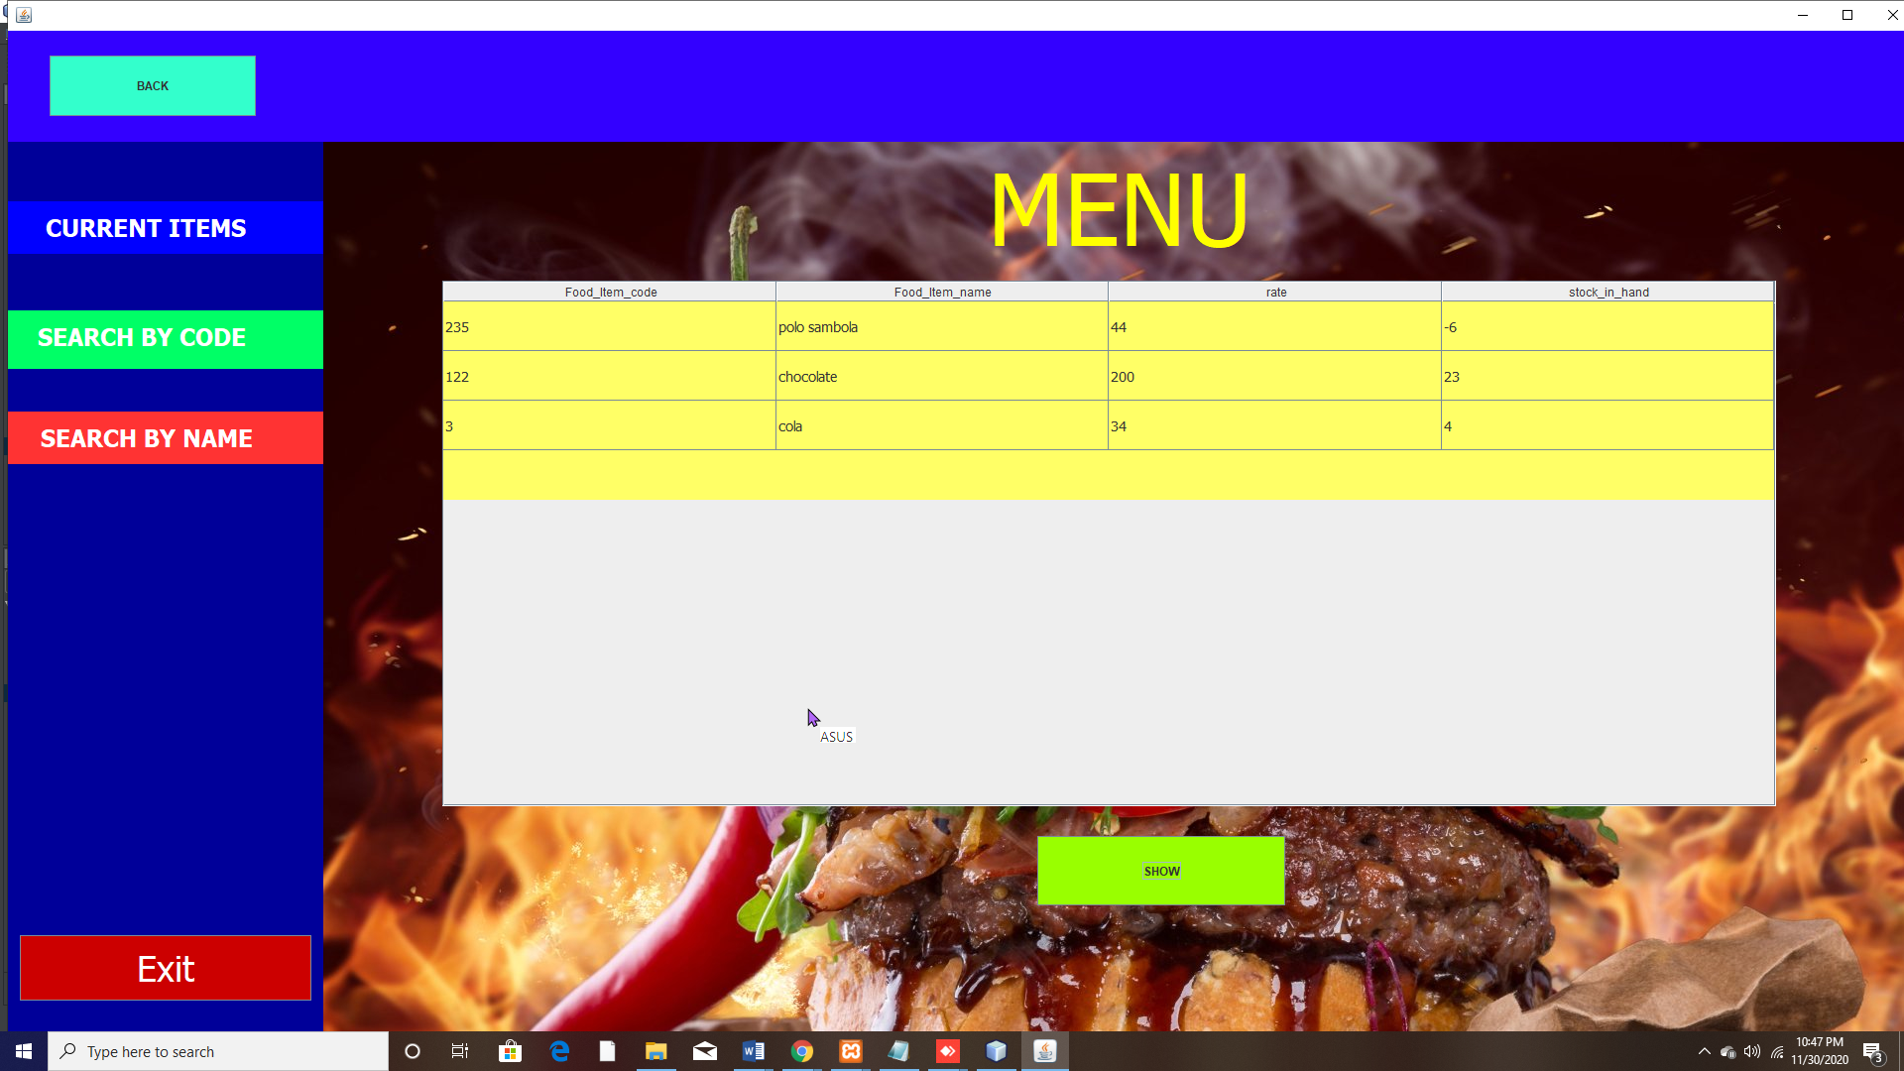

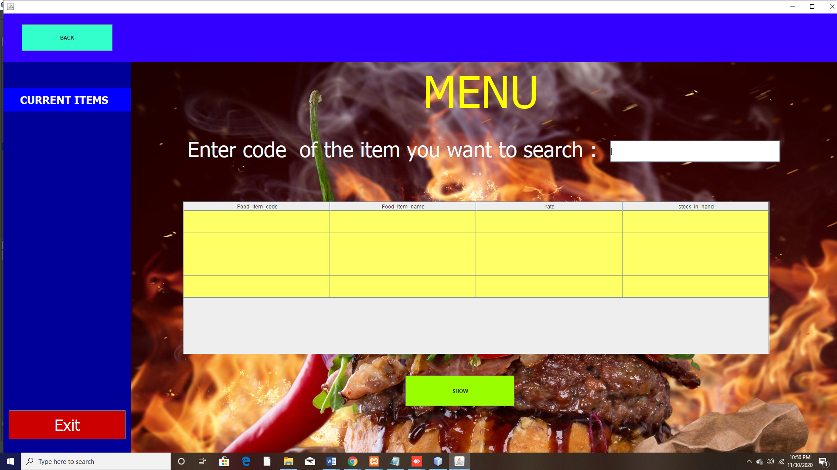

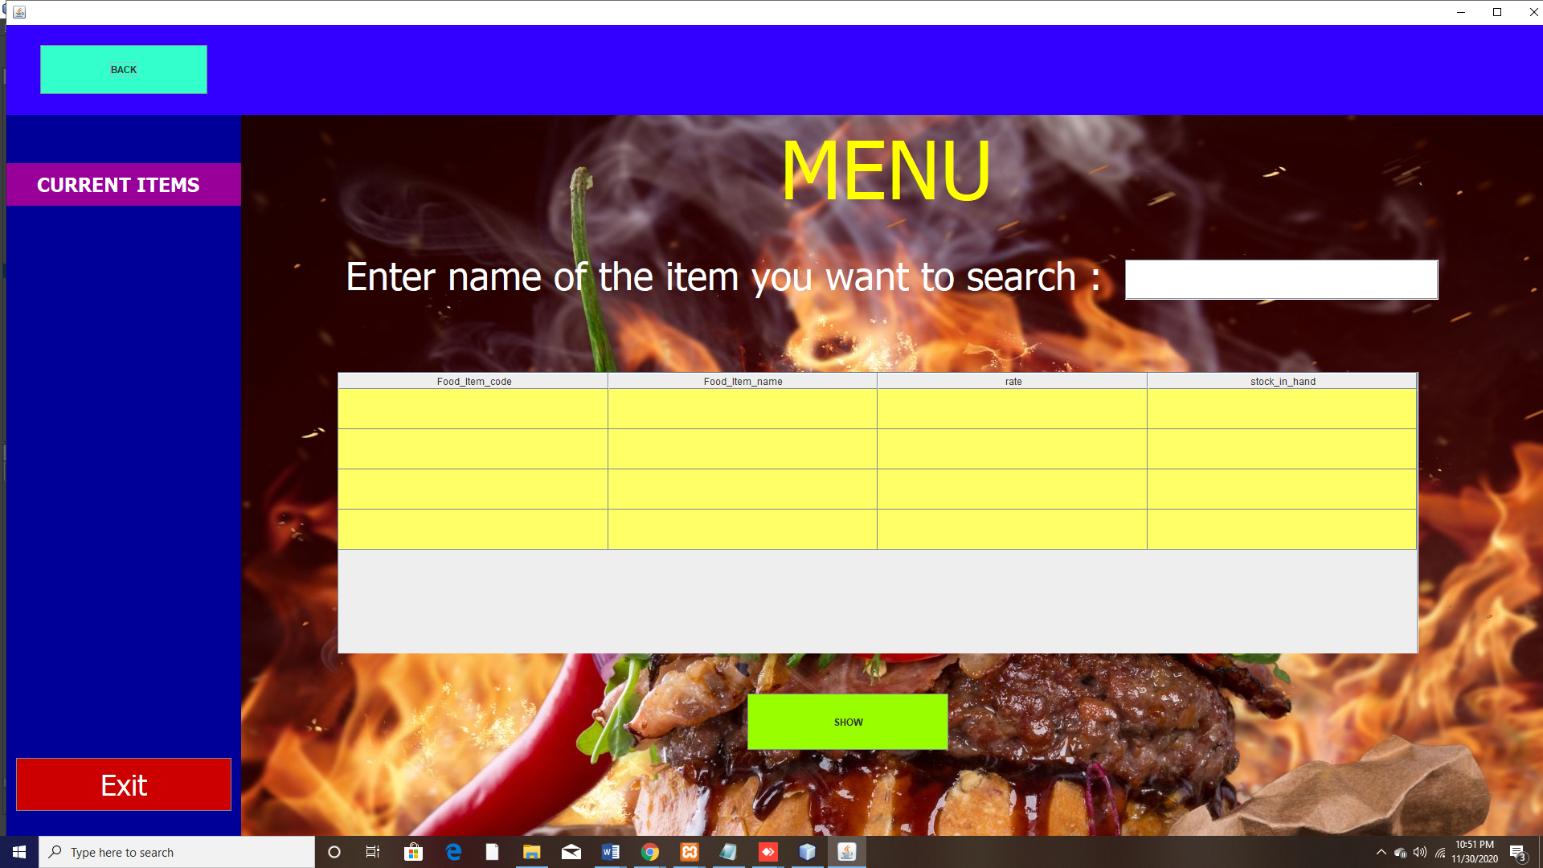

Employee panel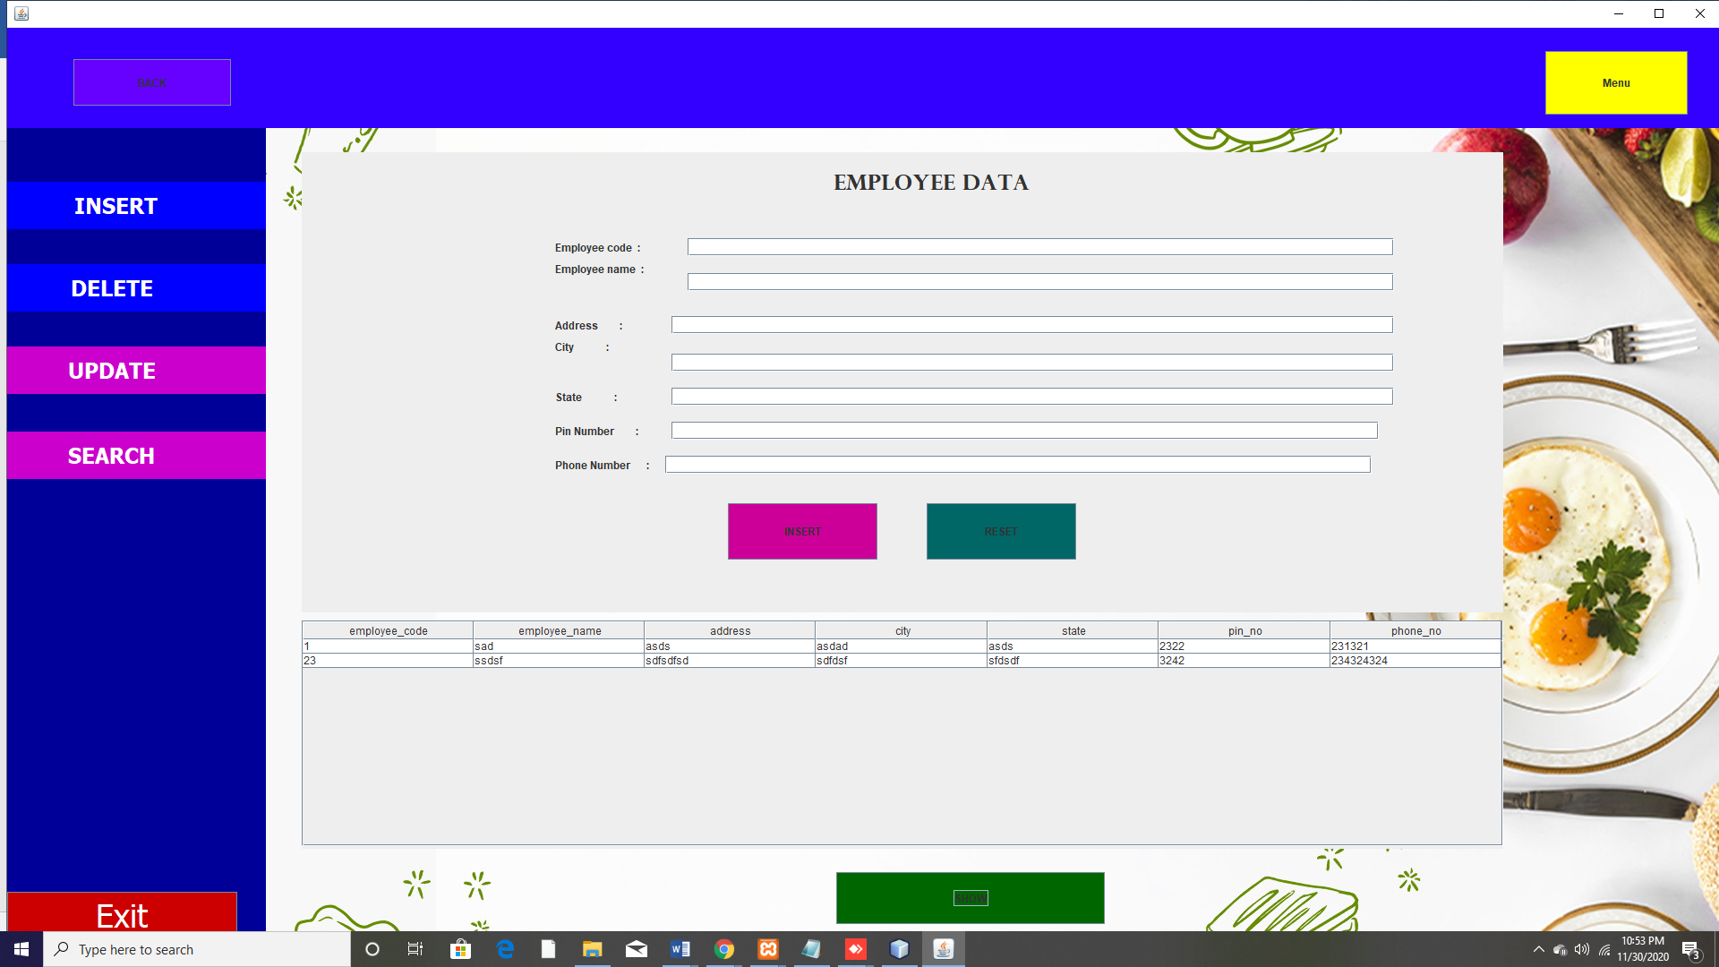

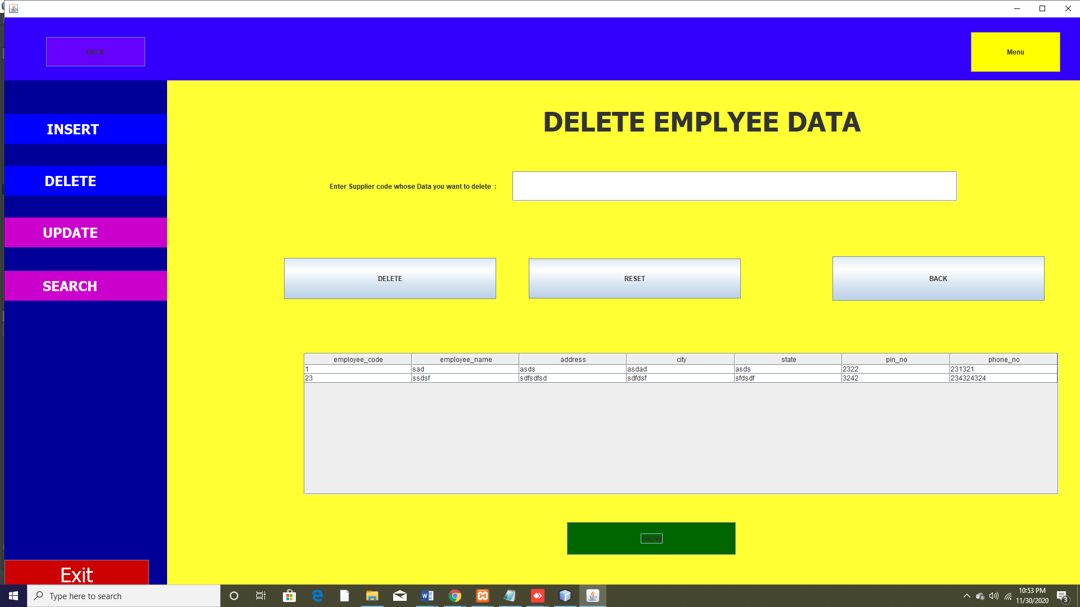

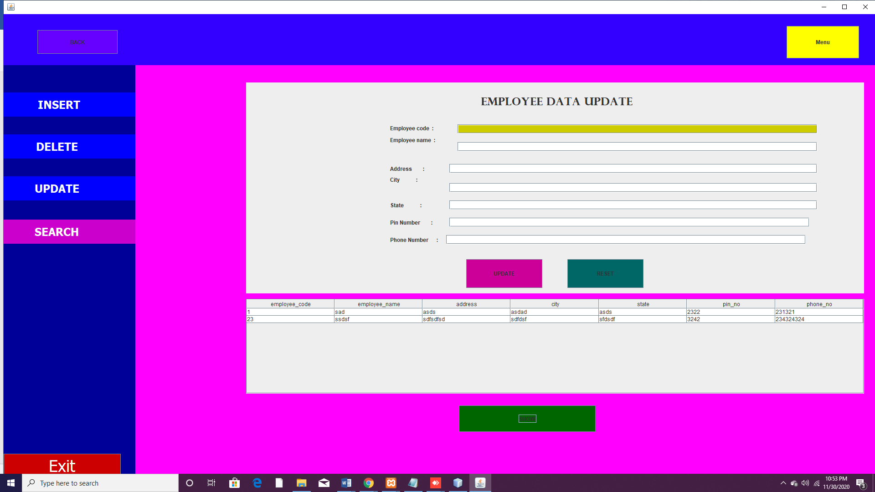

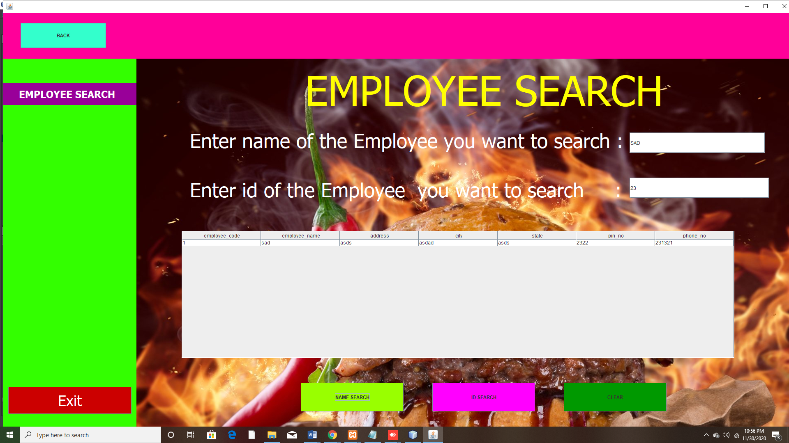

Purchase panel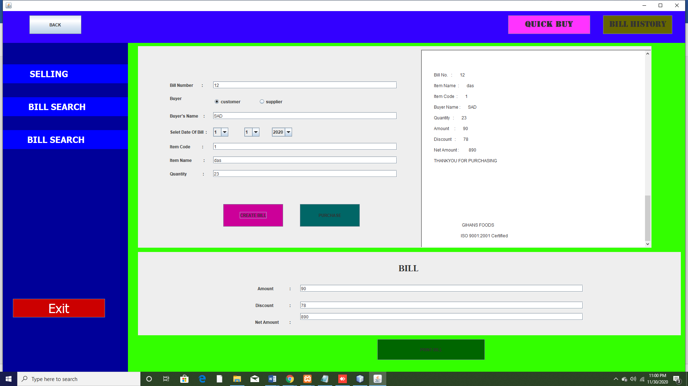

Purchase search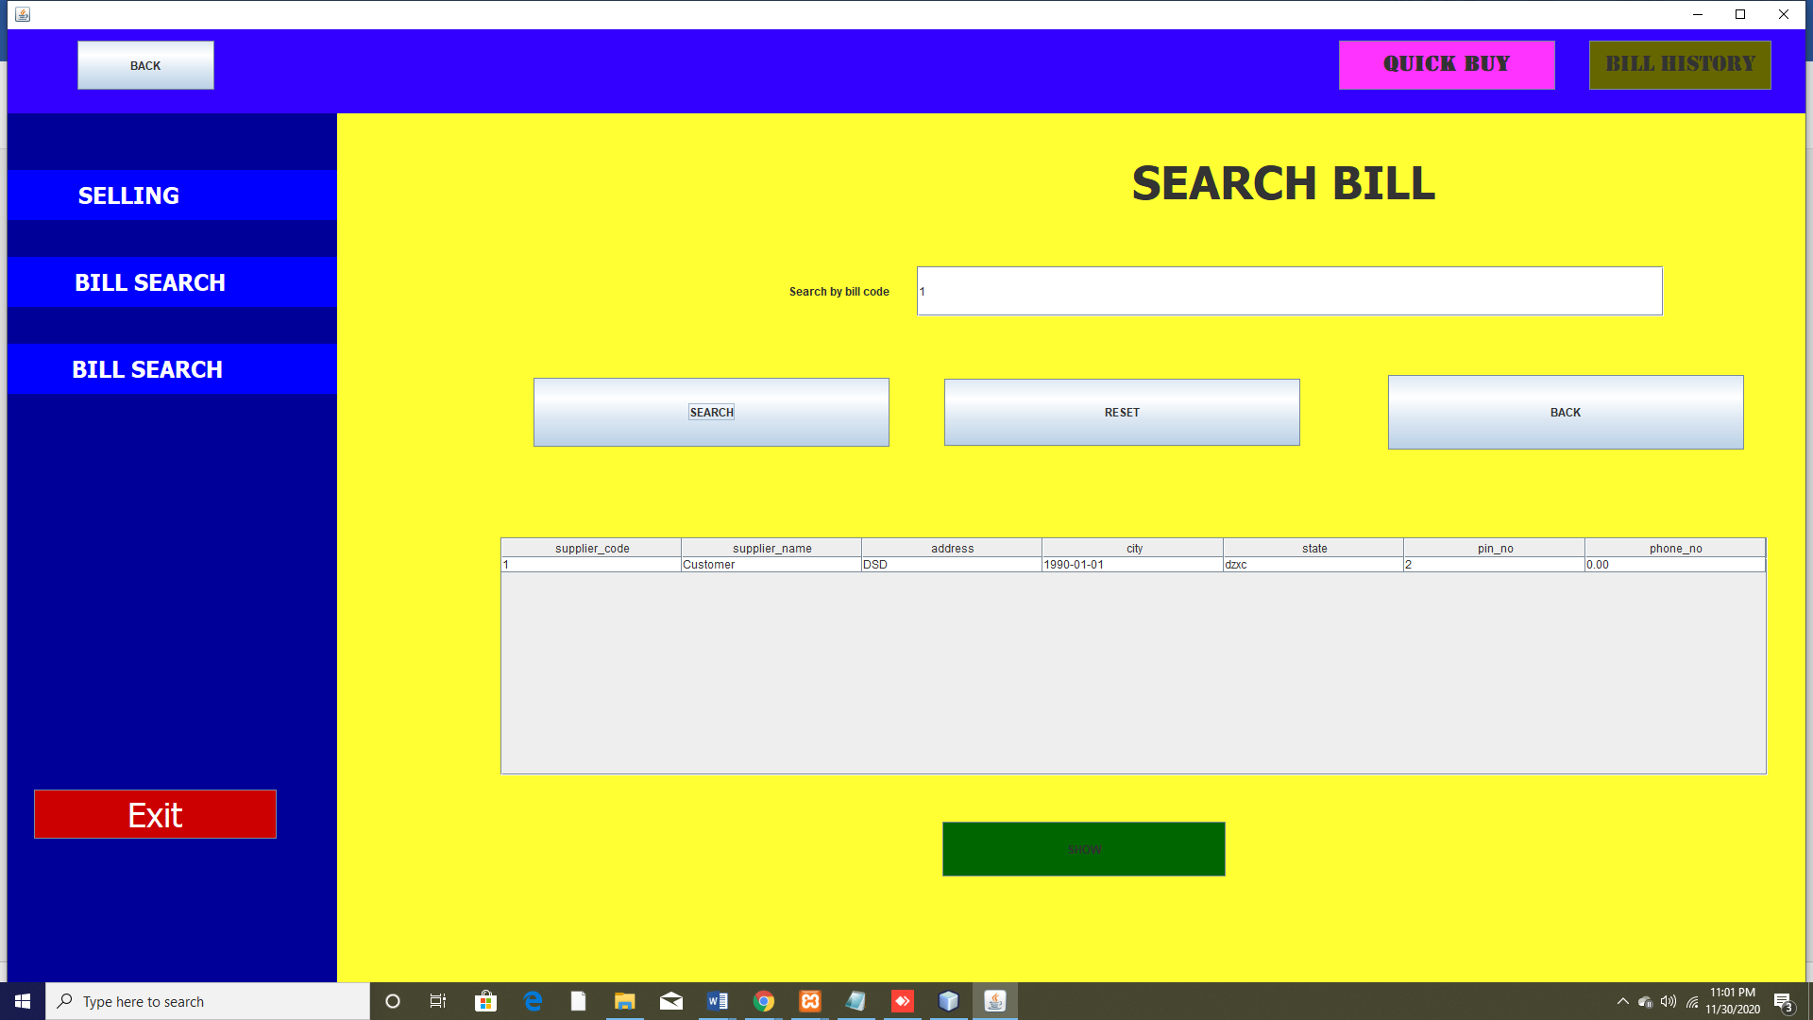

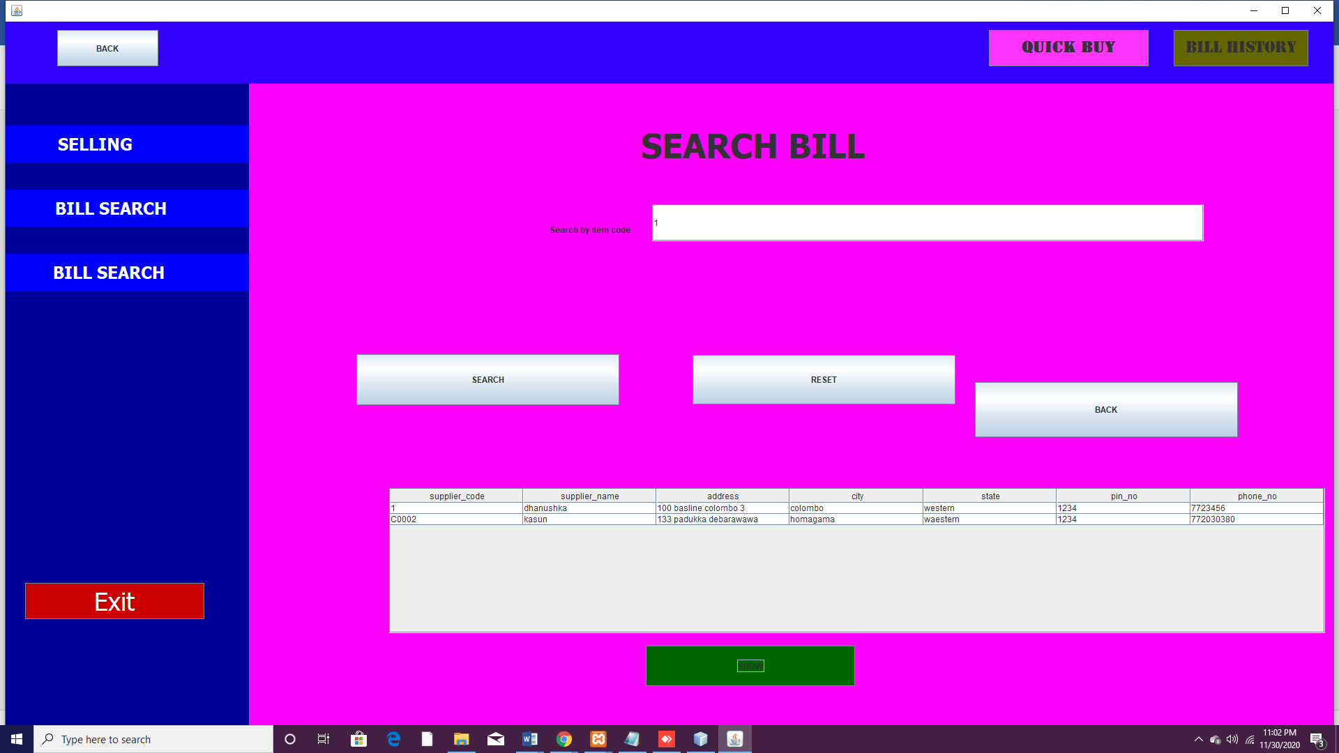

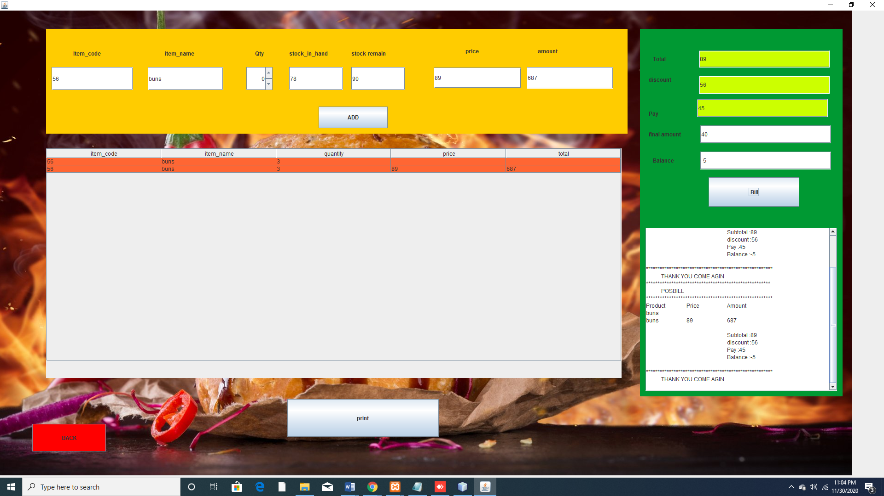

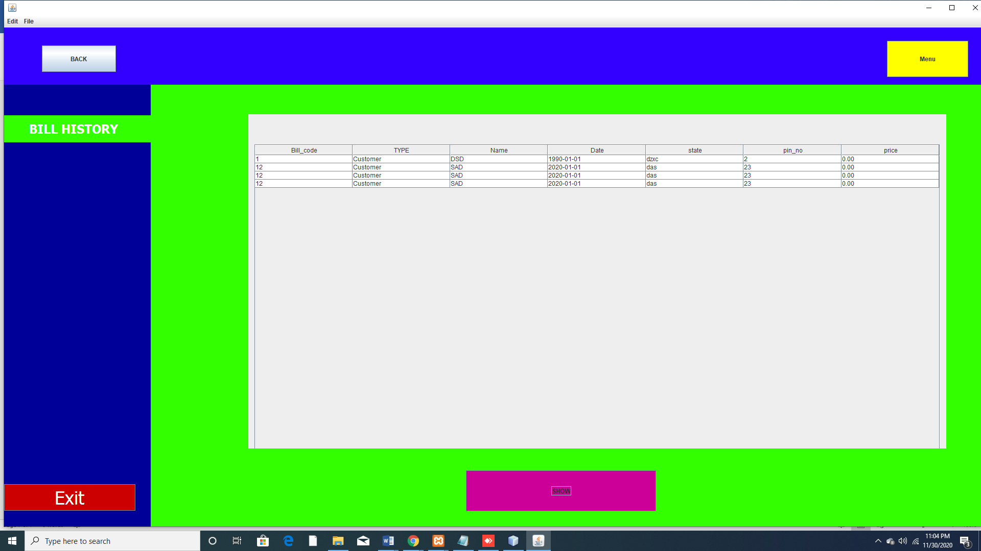

Supplier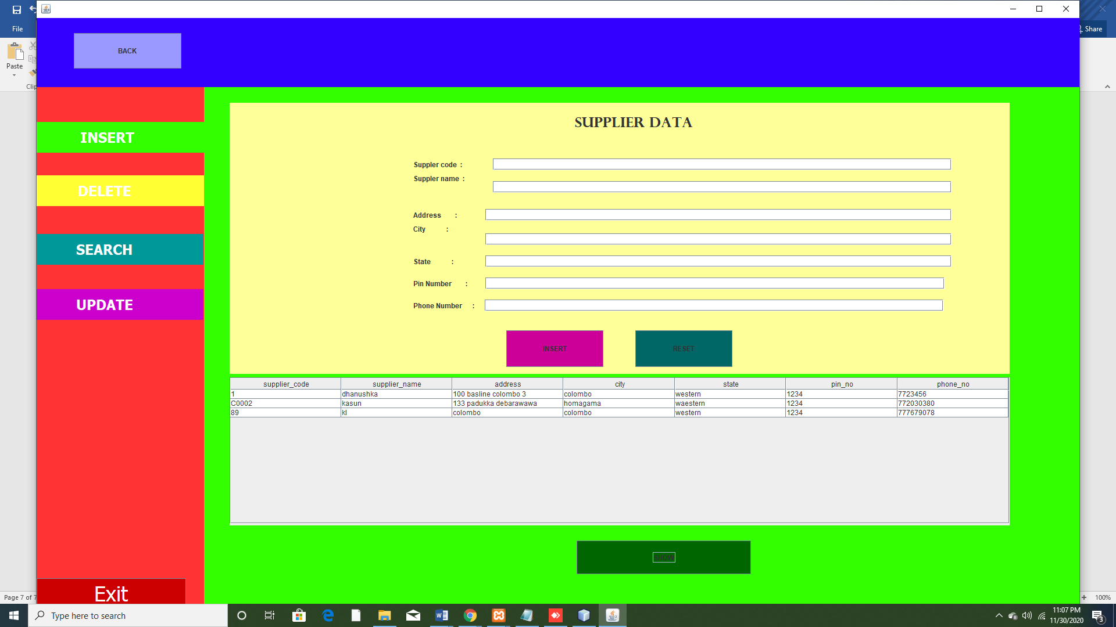

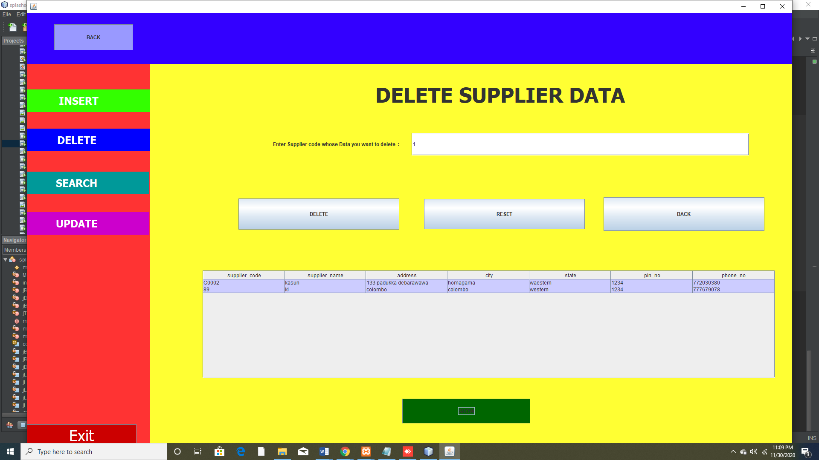

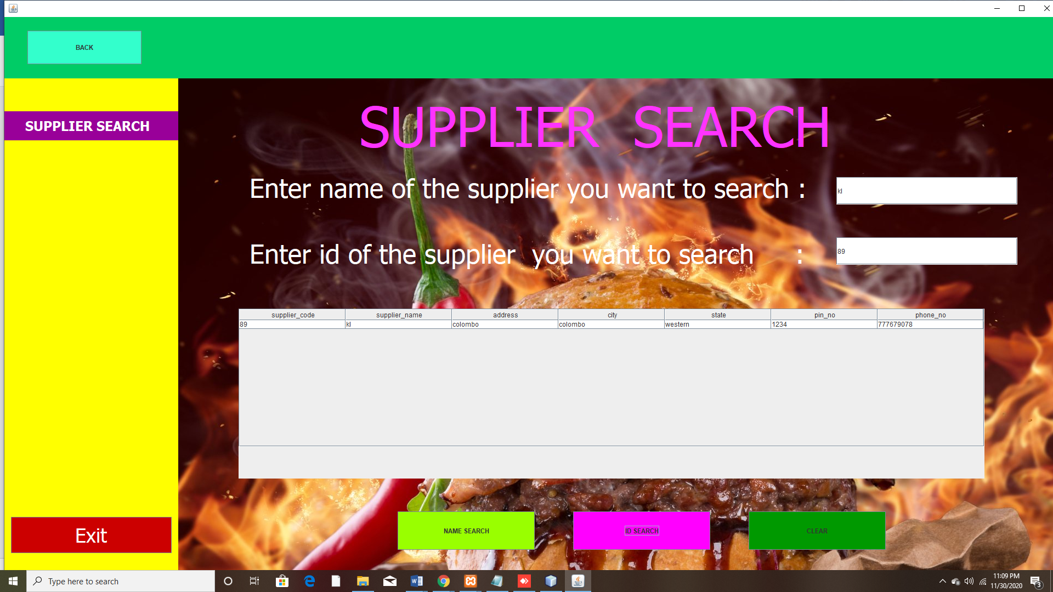

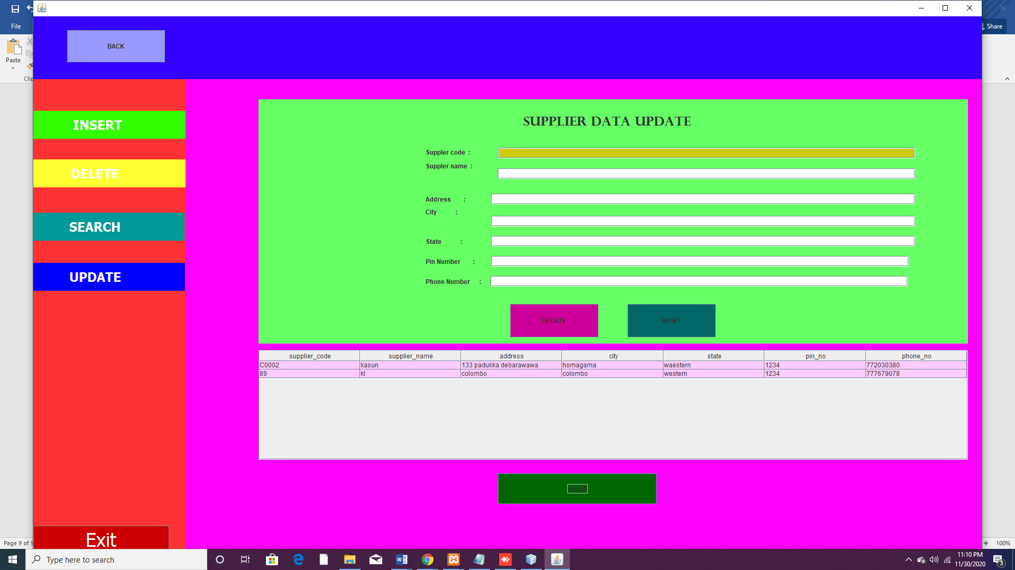

Customer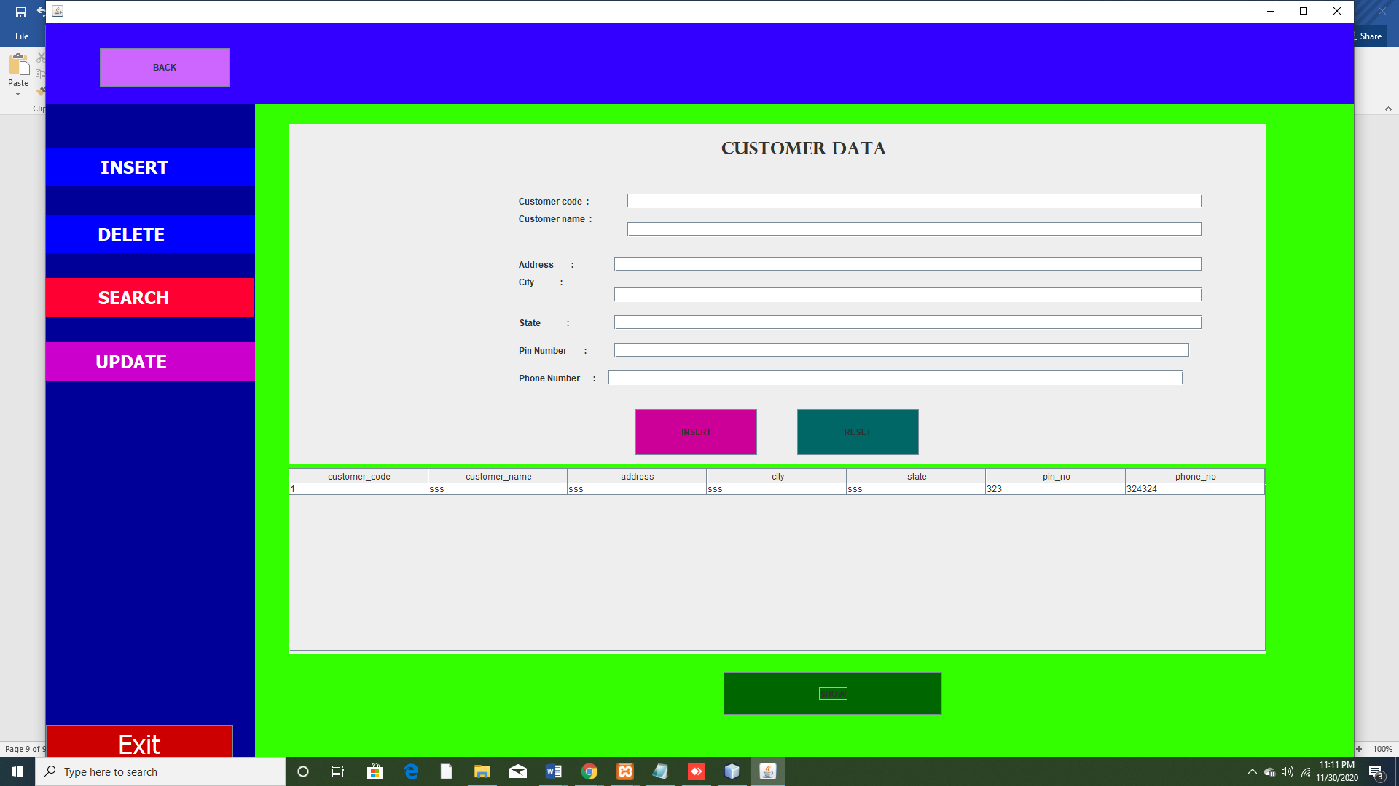

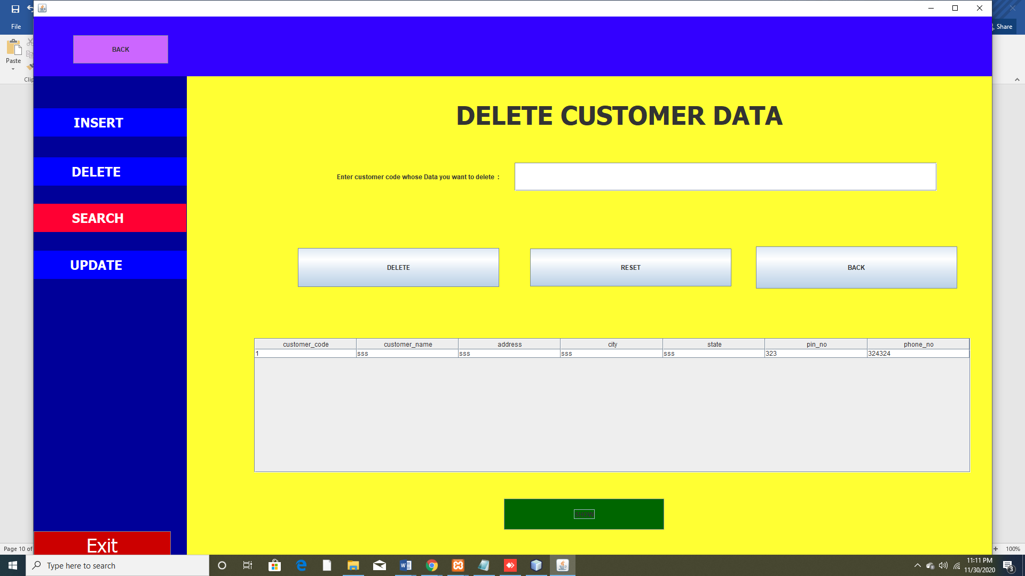

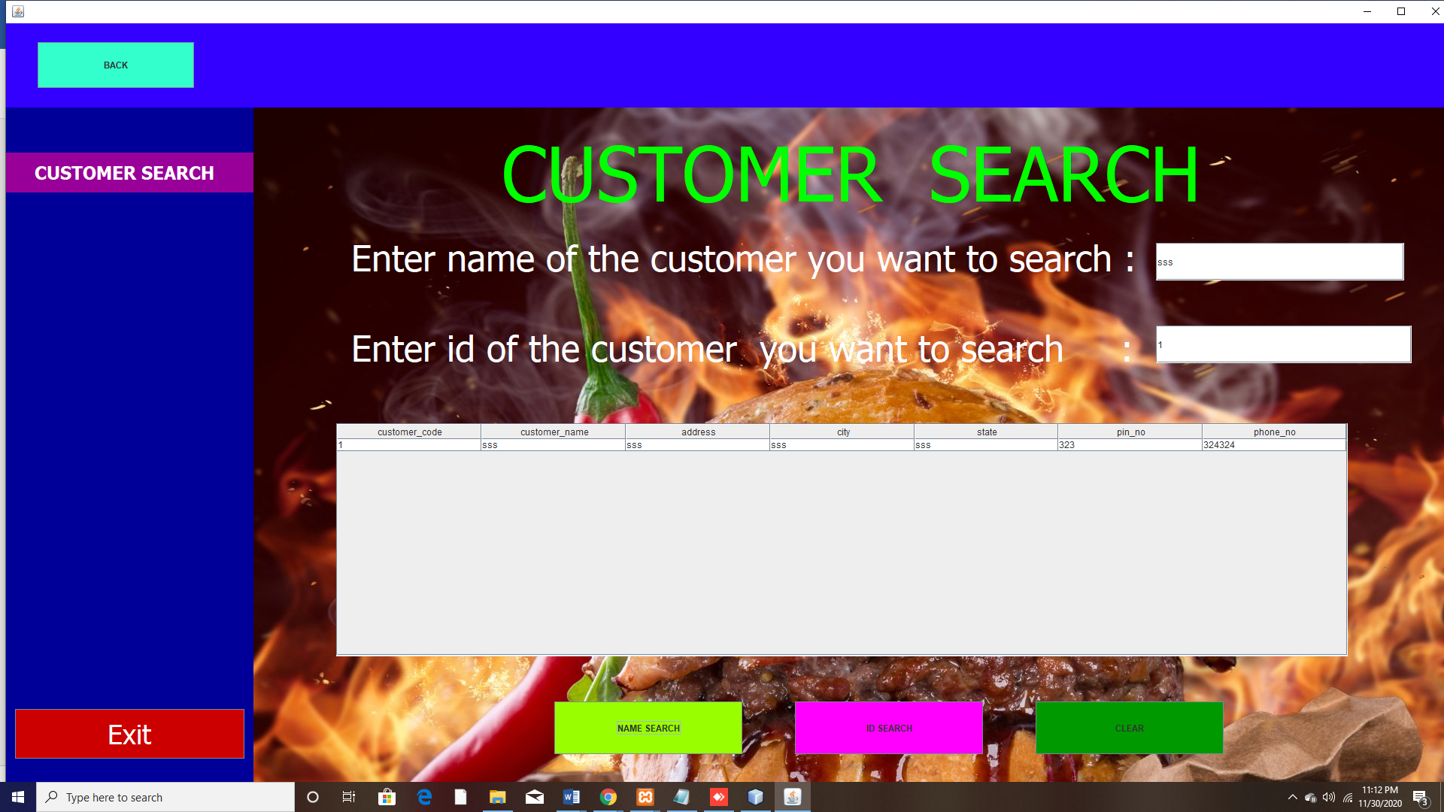

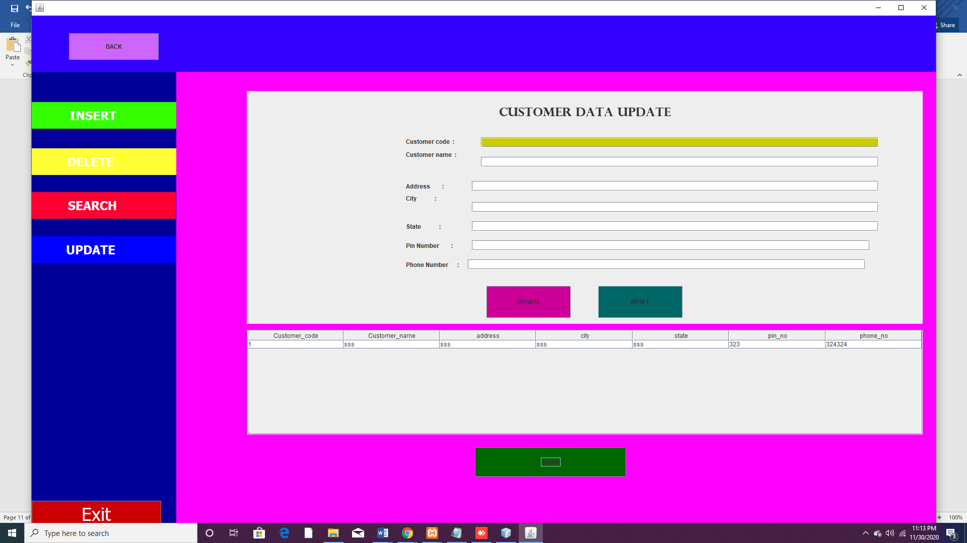

Stock panel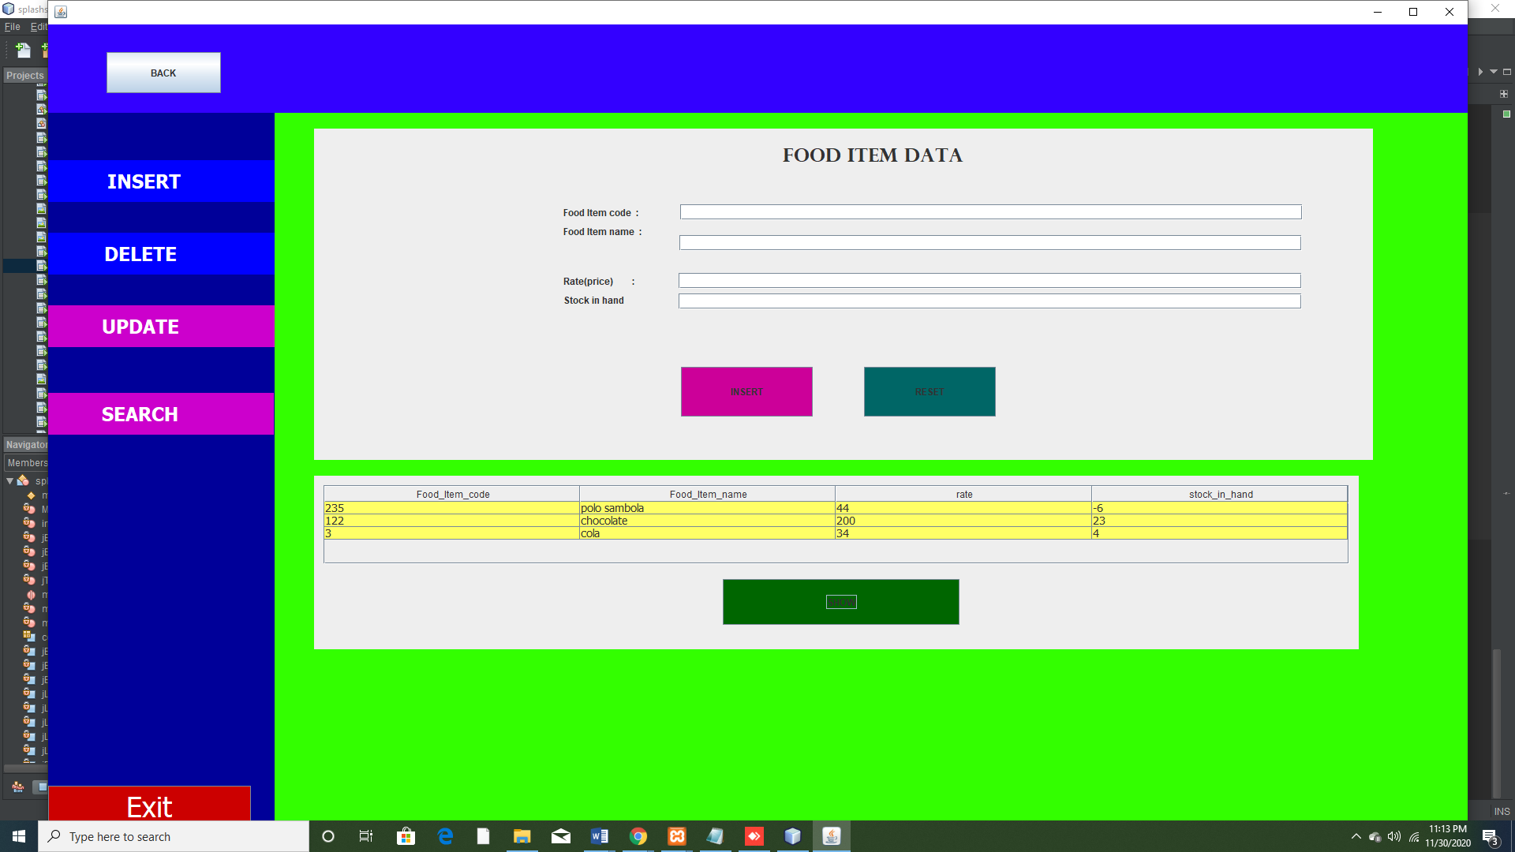

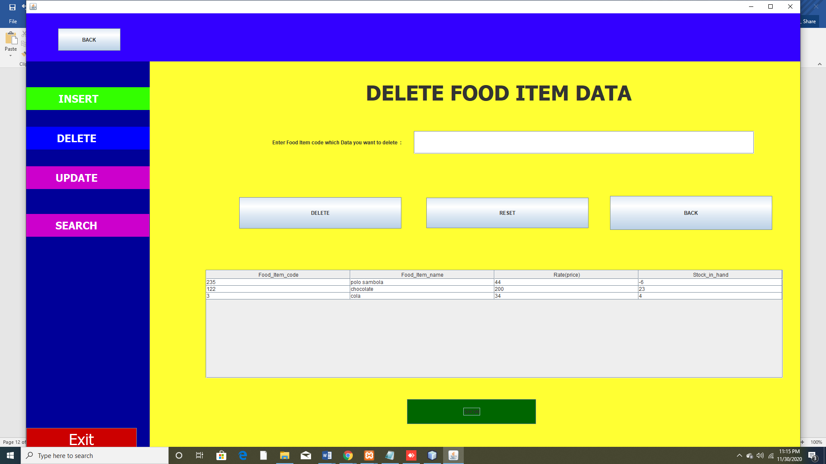

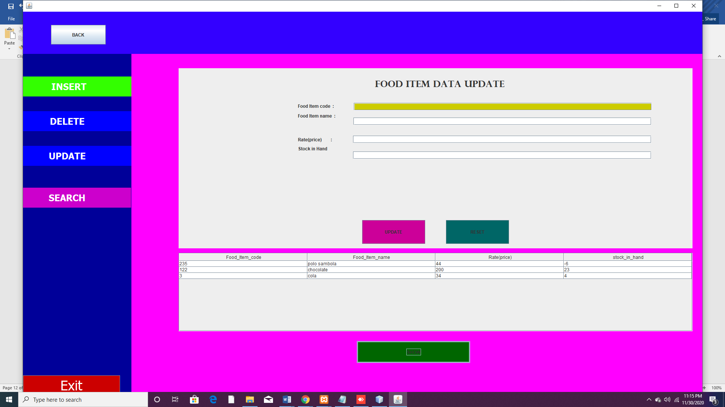

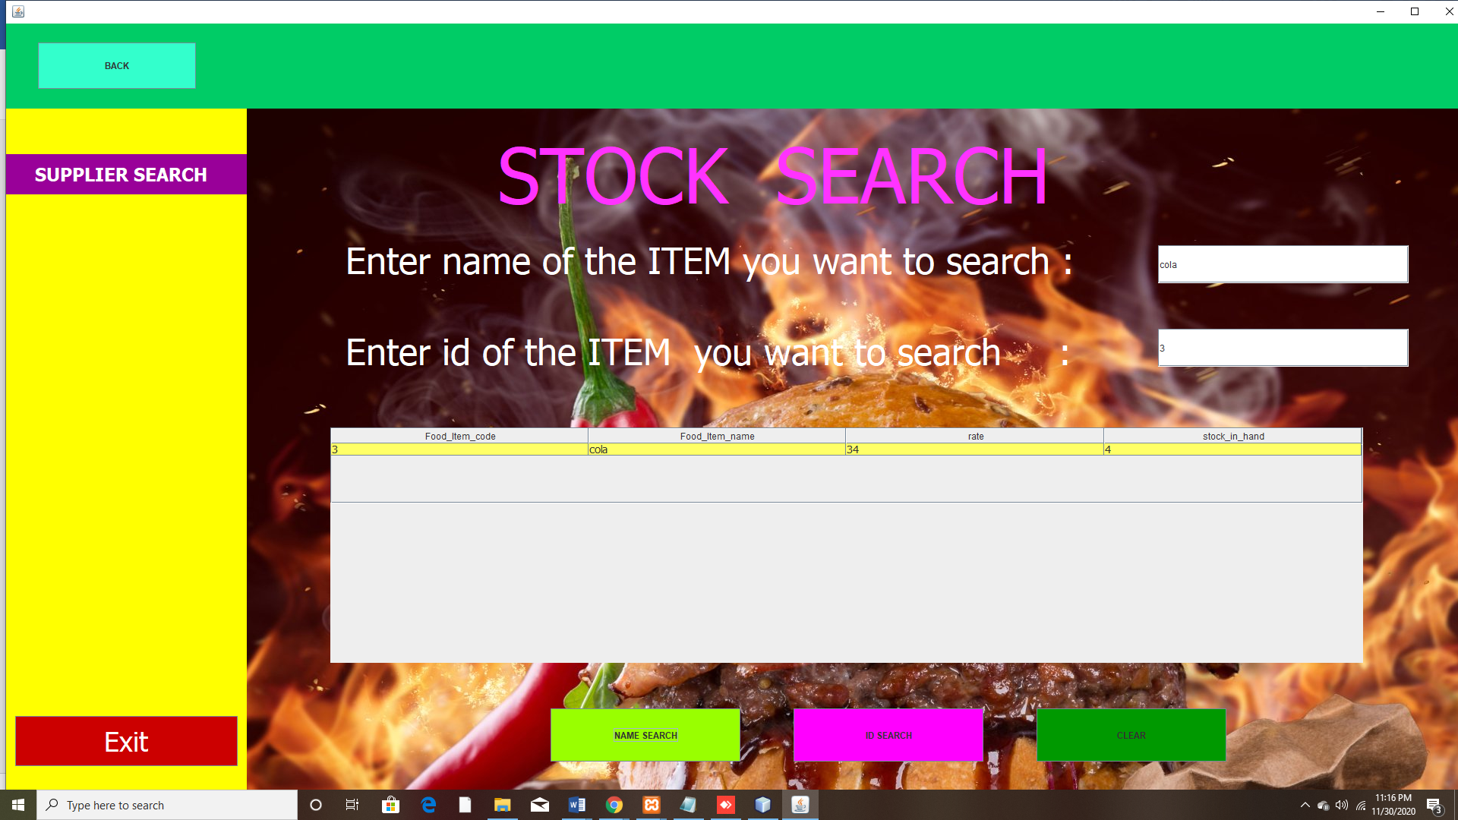

About us

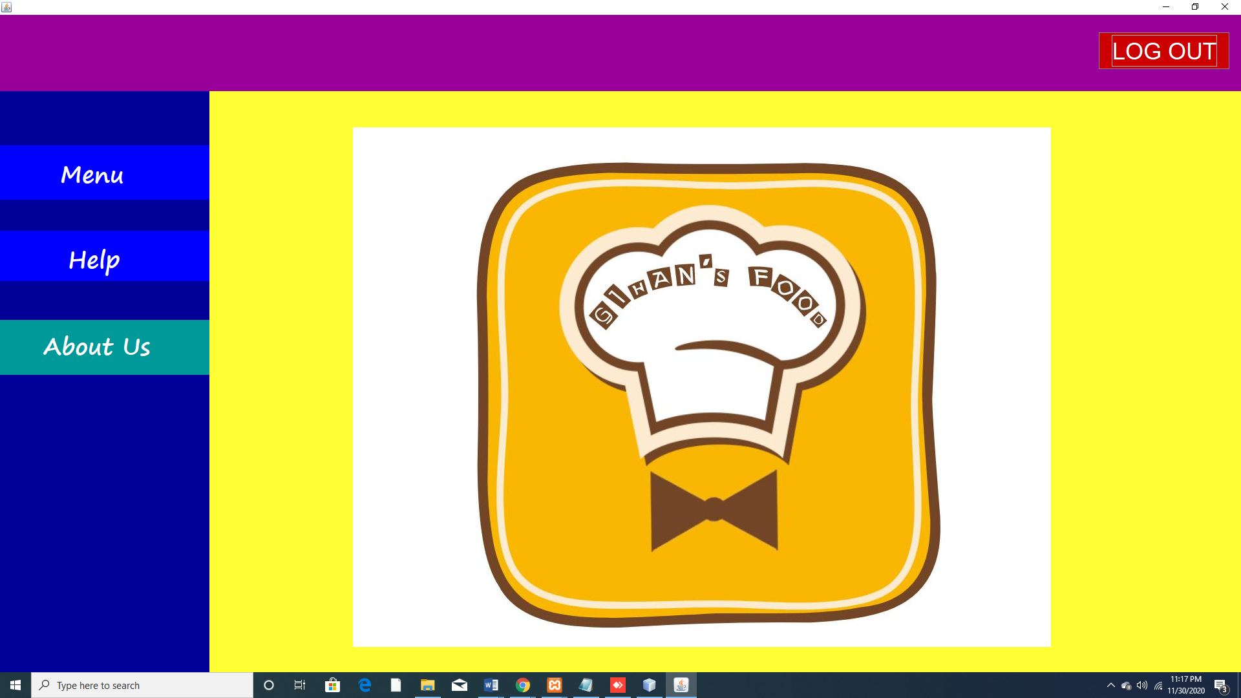

# References

Elysiumservice, n.d. *eibsglobal.* [Online]   
Available at: https://eibsglobal.com/7-amazing-benefits-restaurant-management-software/  
[Accessed 1 12 2020].

|  |  |  |  |  |  |  |
| --- | --- | --- | --- | --- | --- | --- |
| Member  Activity | Member 01 ID:10707202 | Member 02 ID:10707193 | Member 03 ID:10707375 | Member 04 ID:10707297 | Member 05 ID:10707428 | Member 06 ID:10707362 |
| ER | R | S | S | S | S | R |
| Use case diagram | S | S | R | S | R | S |
| Class diagram | S | R | S | R | S | S |
| Menu/Dashboard | S | S | S | R | S | S |
| Employee Details/signup | S | S | S | S | S | R |
| stock | S | R | S | S | S | S |
| supplier | R | S | S | S | S | S |
| Purchase | S | S | R | S | S | S |
| Login/customer | S | S | S | S | R | S |
| Total contribution | 16.6% | 16.6% | 16.6% | 16.6% | 16.6% | 16.6% |